

25CSSE01C

Software Engineering I

Phase 1 - Report

Project Title: Pharmacy Delivery System
Group #: 40
T. A. Name: Zeina

Table of Contents
1. Contribution Table: 2
2. Project Description: 3
3. Functional Requirements: 4
4. Non-Functional Requirements: 5
5. Context Diagram (Group): 5
6. Use Case Diagram (Group): 6
7. Use Case Scenario (Individual): 7
7.1. Manage Inventory (Youssef Adel – 258270 ) 8
7.2. Assign Courier (Tarek Saeed - 252382) 8
7.3. Manage Profile (Yosef Osama - 255796) 9
7.4. Track Order Statues (Yousif Hafez - 258612) 11
7.5. Manage Order (Yousef Mohiey - 248679) 12

Contribution Table:

ID | Student Name | Contribution
258270 | Youssef Adel | Functional Requirements (FR-01), Use Case Scenario 1
248679 | Yousef Mohamed Mohiey | Functional Requirements (FR-02), Use Case Scenario 5
258612 | Yousif Hafez Momtaz | Functional Requirements (FR-04), Use Case Scenario 4
255796 | Yosef Osama Gad | Functional Requirements (FR-05), Use Case Scenario 3
252382 | Tarek Saeed | Functional Requirements (FR-03), Use Case Scenario 2

Project Description:
Pharmacy Delivery System
The system must maintain an accurate inventory of medicines, including pricing and stock levels, alongside a secure database of customer profiles and verified delivery addresses. Students must define a multi-stage
OrderWorkflowthatbegins with orderplacementand continues through to "Dispatch" and "FinalDelivery." A core requirement is the Courier Assignment Module, which allows administrators to assign delivery personnel to specific orders based on priority or location. Additionally, the system must provide Real-time Status Tracking (e.g., Pending, Out for Delivery, Delivered) to ensure order accuracy and provide transparency for both the pharmacy and the end-user.

Functional Requirements:

Function | Description
Manage Inventory | The system shall allow authorized pharmacy staff to manage medicine inventory including pricing, stock levels, and product details.
Manage Order | The system shall allow customers to process orders from placement through to dispatch and final delivery.
Assign Courier | The system shall allow administrators to assign couriers to order based on priority or location.
Track Order-Status | The system shall allow customers and staff to track order status with real-time updates (Pending, Out for Delivery, Delivered).
Manage Profile | The system shall allow customers to manage customer profiles, including verified delivery addresses and contact information.

Non-Functional Requirements:

- Performance: Order status updates must reflect within 5 seconds of status change.
- Security: Customer data must be encrypted using AES-256 standards.
- Availability: System must have 99.9% availability during peak hours (6 PM - 10 PM).
- Compliance: System must comply with local pharmacy data protection laws.
- Usability: First-time users shall complete an order in under 5 minutes without assistance.

Context Diagram (Group):

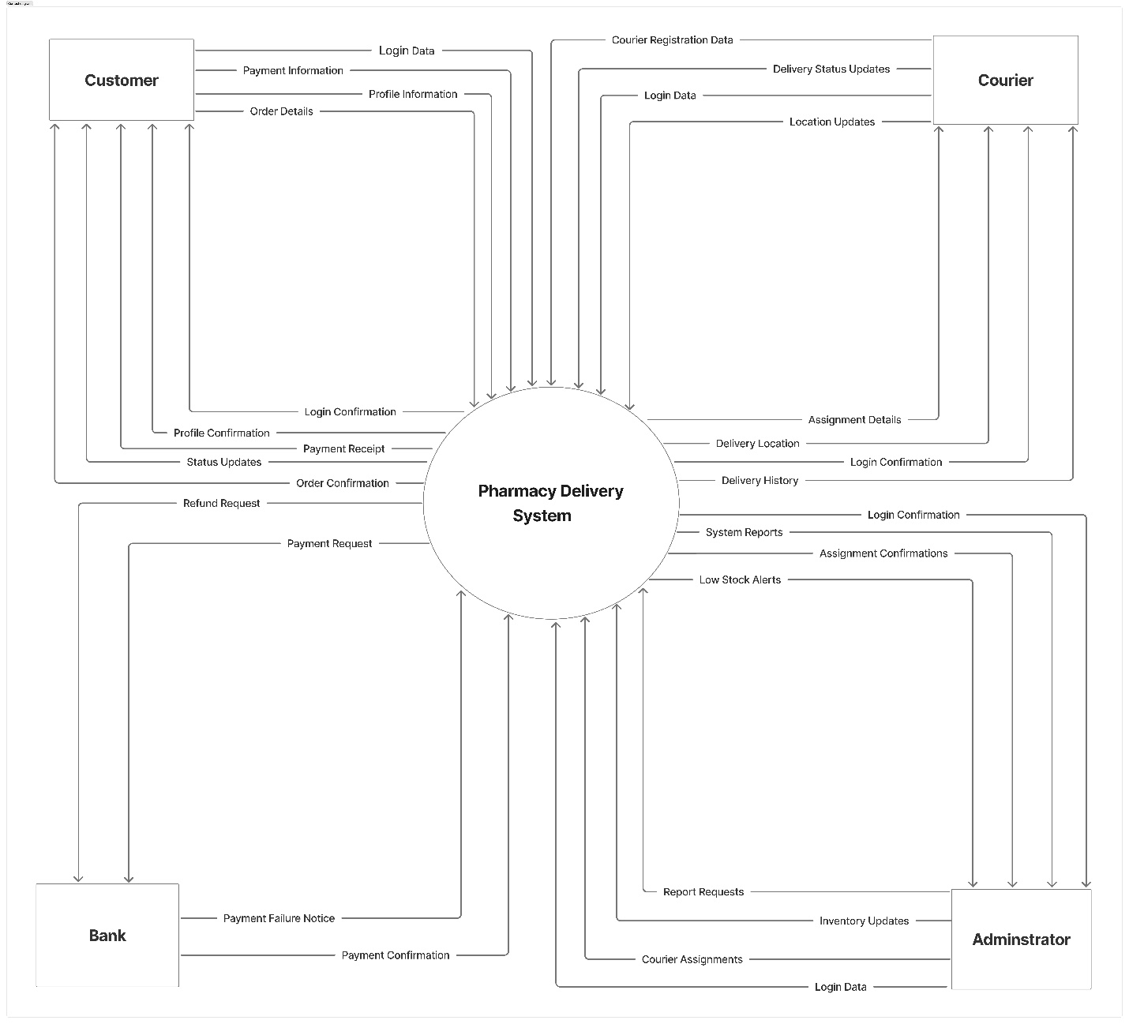

Use Case Diagram (Group):

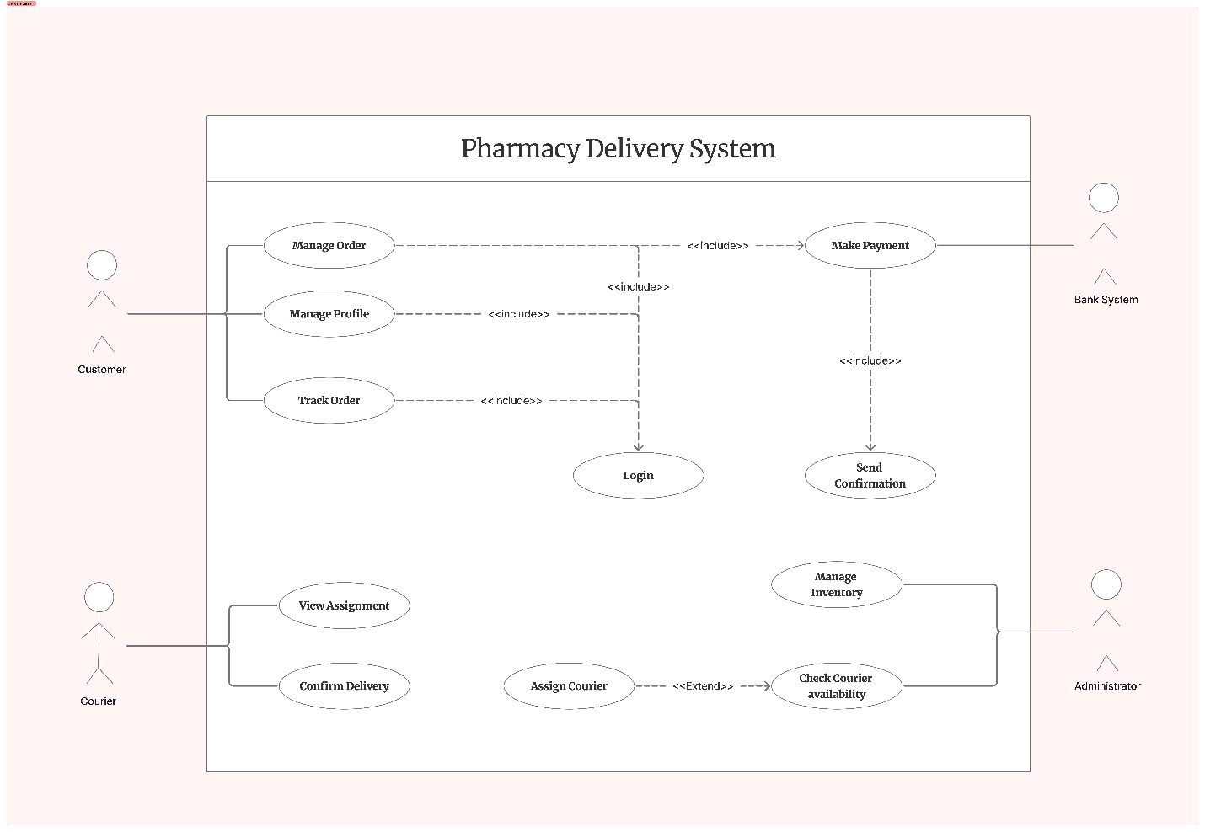

Use Case Scenario (Individual):

Manage Inventory (Youssef Adel – 258270 )

ID: | UC_01
Title: | Manage Inventory
Description: | Admin manages medicine inventory including stock and pricing.
Priority | High
Primary Actor: | Admin/Pharmacist
Secondary Actor: | N/A
Preconditions: | • Admin is logged in  • Admin has inventory management permissions
Postconditions: | • Inventory database is updated  • Stock levels reflect changes  • Confirmation message displayed to Admin
Main Success Scenario: | 1. Admin navigates to inventory management page  2. Admin searches for medicine by name or ID  3. Admin views current stock  4. Admin enters new quantity/price and clicks (Save Changes)  5. System saves changes and displays confirmation
Extensions: | • 2a - Medicine not found ( "Add new medicine" option displayed )  • 3a - Invalid data entered ( Error message displayed )  • 5a - Database error ( Error message, changes not saved )  • 6a - Admin clicks 'Cancel' ( Changes discarded, returns to inventory page )

Assign Courier (Tarek Saeed - 252382)
ID: | UC_02
Title: | Assign Courier
Description: | The system allows administrators to assign delivery personnel to specific orders.
Priority | High
Primary Actor: | Administrator
Secondary Actor: | Courier
Pre-conditions: | Order status is "Pending".  Couriers are available.
Post-conditions: | Order status updates to "Dispatch".  Courier receives assignment notification.
Main Success Scenario: | Admin views pending orders list.  Admin selects order based on priority/location.  Admin selects available courier.  System assigns courier to order.  System notifies courier.
Extensions: | No couriers available. System alerts Admin to wait or outsource.  Courier is offline. System suggests next available courier.  Assignment conflict (Courier already assigned). System blocks action.

Manage Profile (Yosef Osama - 255796)
ID: | UC_03
Title: | Manage profile
Description: | Allows customers to view, update, and maintain their personal information
Priority | High
Primary Actor: | Customer
Secondary Actor: | Bank System
Pre-conditions: | The Customer needs to have a system registration.  The Customer needs to log in successfully (Register/Login).
Post-conditions: | The system updates and saves the customer profile data.  The system keeps track of profile modifications.
Main Success Scenario | The Customer opens the "Manage Profile" section  The system shows the most recent profile data.  The customer chooses which information (personal information, addresses, payment methods, or preferences) to update.  The system displays an editable form  The Customer adds or modifies data  The system verifies the data entered.  The system stores updated data  The system verifies that the update was successful.  The Customer sees the confirmation message
Extensions: | Incorrect information entered:The system shows an error message Information is corrected by the customer  Error in the system while saving .The system shows an error message. The client may cancel or try again. Resuming the end use case or step five

Track Order Statues (Yousif Hafez - 258612)
ID: | UC_04
Title: | Track Order Statues
Description: | The system shall display the current order status in real time, showing stages such as Pending, Processing, Out for Delivery, and Delivered.
Priority | High
Primary Actor: | Customer
Secondary Actor: | Admin / Pharmacy Staff / Courier
Pre-conditions: | • User should have already placed an order.  • Order should exist in the system.  • User should be logged into the system or have access to the order details.
Post-conditions: | • The system displays the latest order status successfully.  • User is informed of the current delivery stage of the order.
Main Success Scenario: | 1. User opens the system/application.  2. User navigates to the order history or current orders page.  3. User selects the order they want to track.  4. System retrieves the latest order information.  5. System displays the current order status (Pending, Processing, Out for Delivery, Delivered).  6. User views the order progress
Extensions: | 1. The selected order may be invalid or unavailable, so the system displays an error message and asks the user to choose a valid order.  2. The system may fail to retrieve the latest order status, so an error message is displayed asking the user to try again later.  3. Network or connection problems may occur while loading the order status, so the system asks the user to check the connection and retry.

Manage Order (Yousef Mohiey - 248679)
ID: | UC_05
Title: | Manage Order
Description: | This function allows customers to place new orders, modify existing orders, and cancel orders (if status is Pending).
Priority | High
Primary Actor: | Customer
Secondary Actor: | Bank System
Pre-conditions: | • Customer is registered and logged in  • Medicines are in stock (for new orders)  • Order exists in system (for modify/cancel)
Post-conditions: | • For Place: Order created with status "Pending", Payment confirmed  • For Modify: Order details updated, notification sent  • For Cancel: Order status changed to "Cancelled"
Main Success Scenario: | - Customer logs in and opens Manage Orders.  - System shows three options: Place, Modify, or Cancel.  - Customer picks one option:  - Place: Customer adds medicines and delivery address.  - Modify: Customer selects a Pending order and changes details.  - Cancel: Customer selects a Pending order and confirms cancel.  - System checks stock and order status.  - System processes payment through Bank System.  - System updates the order status.  - System sends confirmation to customer.
Extensions: | 3a. Stock not available. System alerts customer. Customer changes order.  3b. Order already shipped. System blocks cancel/modify. Shows error.  5a. Payment fails. System asks retry. Customer selects new payment.  5b. Bank System unavailable. System saves as Pending Payment. Notifies customer to retry later.

